UNIT-1
LEET CODE EXERCISE
1. Big Countries
Problem Summary
You are given a table World with the following columns:
- name (country name)
- continent
- area (in square km)
- population
- gdp
A country is considered “big” if:
- Its area ≥ 3,000,000, OR
- Its population ≥ 25,000,000
Task
Write an SQL query to return the name, population, and area of all big countries.
SQL Solution
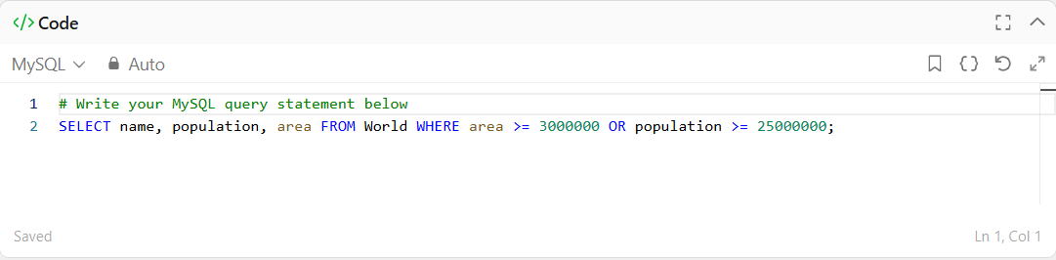
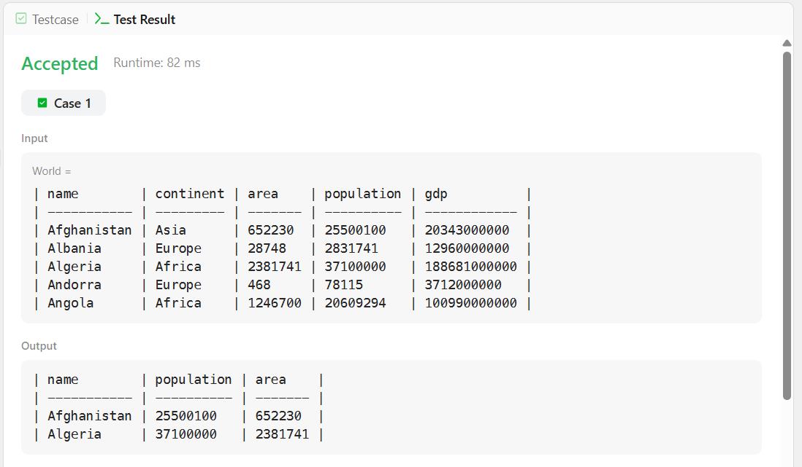
Explanation
- The SELECT clause retrieves required columns.
- The WHERE clause filters records based on the given conditions.
- The OR operator ensures that even if one condition is satisfied, the country is included.
2. Find Customer Referee
Problem Summary
You are given a table Customer with the following columns:
- id (customer ID)
- name (customer name)
- referee_id (ID of the referring customer)
Task
Find the names of customers who were NOT referred by the customer with id = 2.
- Note: Customers with NULL in referee_id should also be included.
SQL Solution
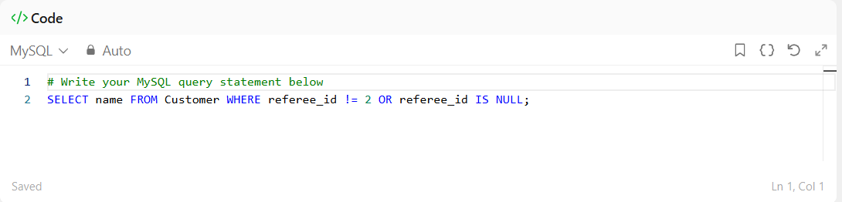
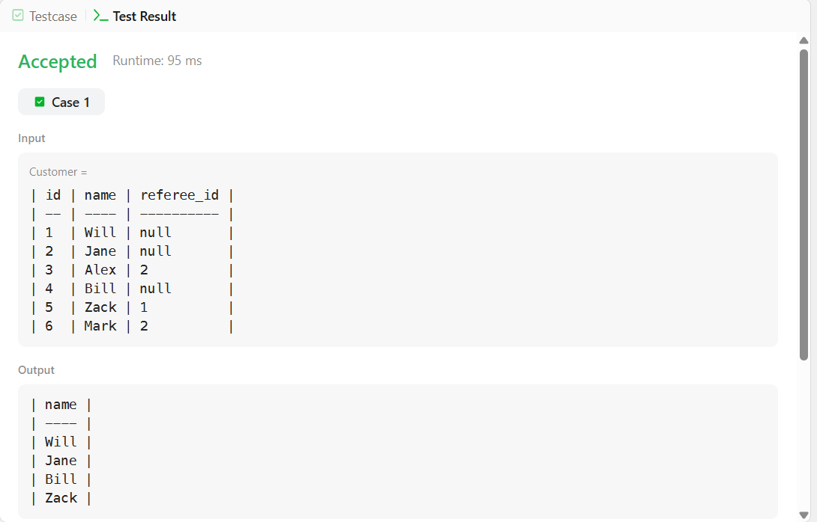

Explanation
- referee_id != 2 → selects customers not referred by ID 2
- referee_id IS NULL → includes customers with no referee
- OR ensures both conditions are considered
3. Not Boring Movies
Problem Summary
You are given a table Cinema with the following columns:
- id (movie ID)
- movie (movie name)
- description (movie type)
- rating (movie rating)
Task
Find all movies that are:
- Not boring → description != 'boring'
- Have odd-numbered IDs → id % 2 = 1
Return the result sorted by rating in descending order.
SQL Solution
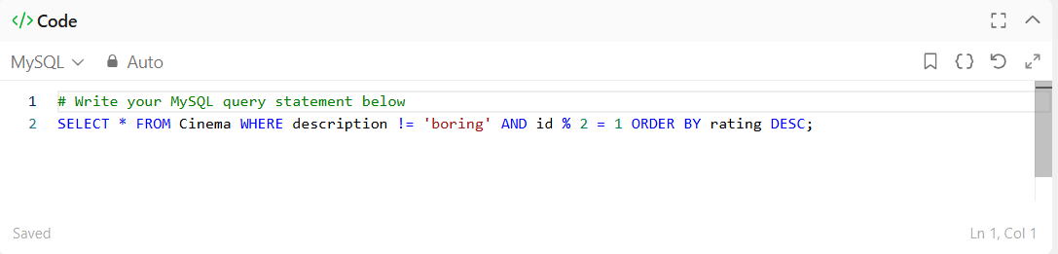
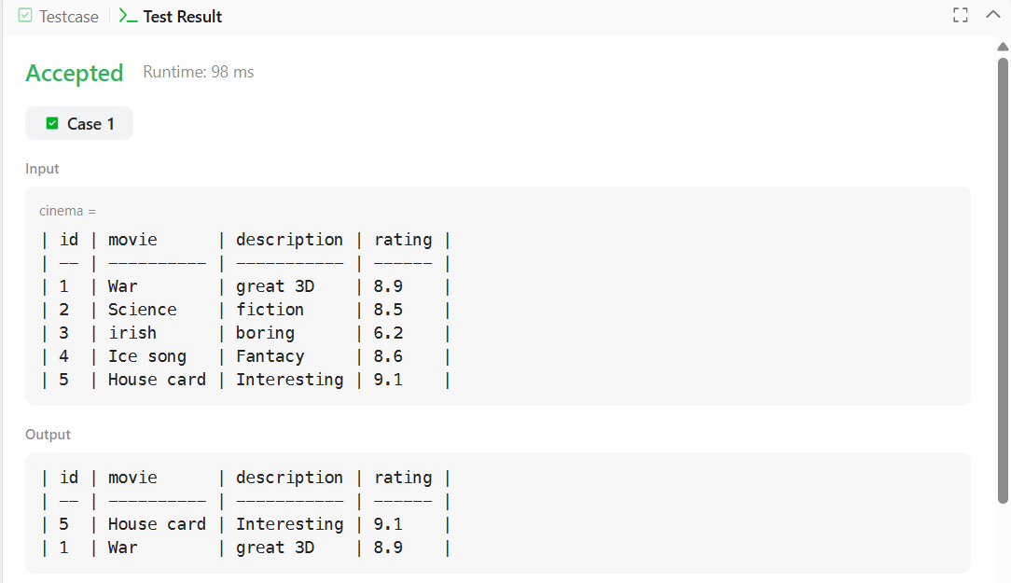
Explanation
- description != 'boring' → filters out boring movies
- id % 2 = 1 → selects only odd-numbered IDs
- ORDER BY rating DESC → sorts results from highest to lowest rating
4. Invalid Tweets
Problem Summary
You are given a table Tweets with the following column:
- tweet_id (ID of the tweet)
- content (text of the tweet)
Task
Find the IDs of tweets that are invalid, where a tweet is considered invalid if:
- The length of the content is greater than 15 characters
SQL Solution
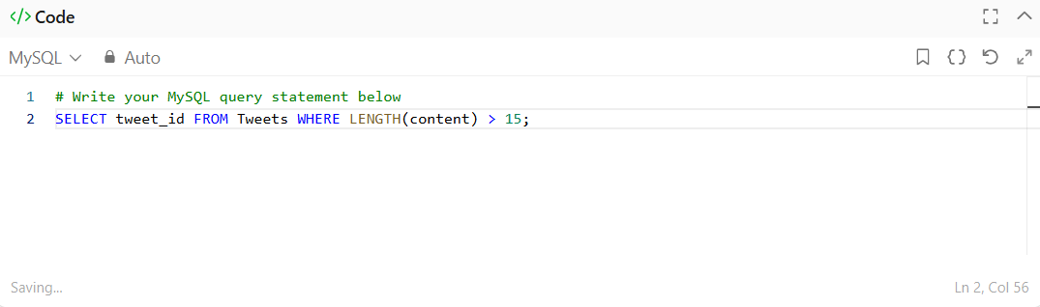
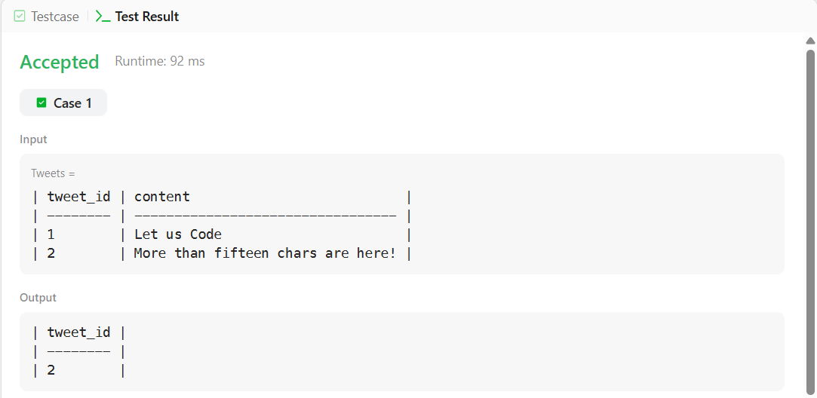

Explanation
- LENGTH(content) calculates the number of characters in the tweet
- 15 filters tweets that exceed the allowed length
- Only tweet_id is returned as required
5. Recyclable and Low-Fat Products
Problem Summary
You are given a table Products with the following columns:
- product_id
- low_fats (values: 'Y' or 'N')
- recyclable (values: 'Y' or 'N')
Task
Find the product IDs of products that are:
- Low fat (low_fats = 'Y')
- Recyclable (recyclable = 'Y')
SQL Solution
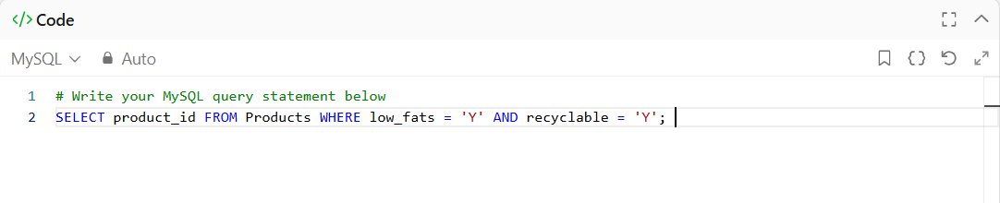
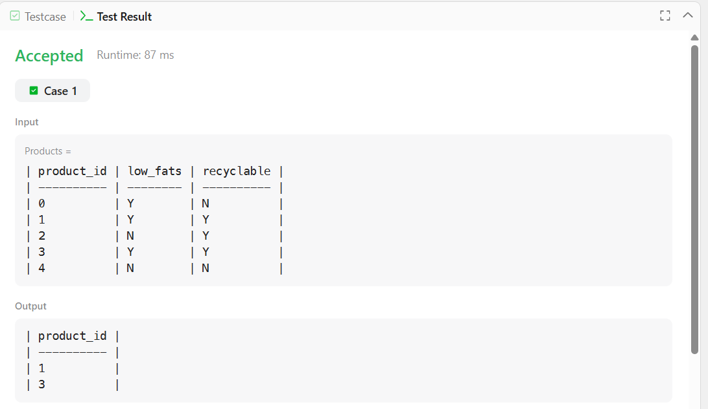

Explanation
- low_fats = 'Y' → selects only low-fat products
- recyclable = 'Y' → selects recyclable products
- AND ensures both conditions are satisfied
6. Article Views
Problem Summary
You are given a table Views with the following columns:
- article_id
- author_id
- viewer_id
- view_date
Task
Find all authors who viewed at least one of their own articles.
- Return the result as a list of unique author IDs
- Sort the result in ascending order
SQL Solution
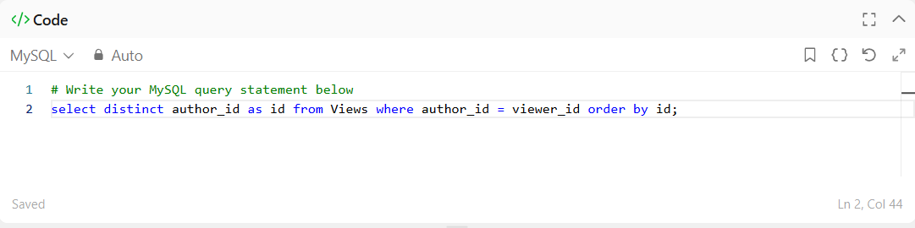
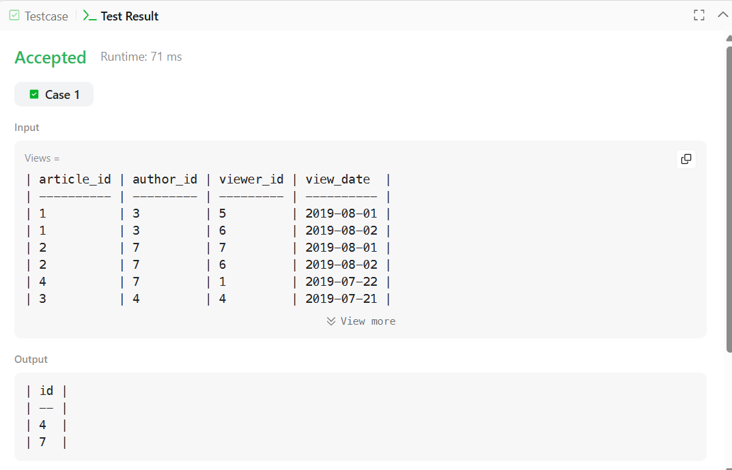

Explanation
- author_id = viewer_id → identifies cases where authors viewed their own articles
- DISTINCT → removes duplicate author IDs
- ORDER BY id → sorts the result in ascending order

